*A project report on*

**INDOOR POSITIONING SYSTEM USING IBeacons**

*Submitted in partial fulfilment for the award of the degree of*

**M.Tech Software Engineering**

*By*

**YALAMADDI ABHINAV (17MIS7077)**



**AMARAVATI**

**COMPUTER SCIENCE**

JUNE ,2019

**INDOOR POSITIONING SYSTEM USING IBeacons**

*Submitted in partial fulfilment for the award of the degree of*

**M.Tech Software Engineering**

*by*

**YALAMADDI ABHINAV (17MIS7077)**



**AMARAVATI**

**COMPUTER SCIENCE**

JUNE ,2019

**CERTIFICATE**

This is to certify that the thesis entitled “INDOOR POSITIONING SYSTEM USING IBeacons” submitted by YALAMADDI ABHINAV (17MIS7077) M. TECH SOFTWARE ENGINEERING, VIT-AP, for the award of the Summer Internship for the bonafide work carried out by him/her under my supervision.

The contents of this report have not been submitted and will not be submitted either in part or in full, for the award of any other degree or diploma in this institute or any other institute or university. The Project report fulfils the requirements and regulations of VIT-AP and in my opinion meets the necessary standards for submission.

**Signature of the Guide**

**<It should be in the Company Letter Head>**

Date: ……………. …..>

**CERTIFICATE BY THE EXTERNAL GUIDE**

This is to certify that the project report entitled “**TITLE OF THE PROJECT”** submitted by <**STUDENT NAME>(<Reg.No.>)** to VIT-AP in partial fulfilment of the requirement for the award of the degree of <Name of the degree> for the bonafide work carried out by him/her under my guidance. The project fulfils the requirements as per the regulations of this Institute and in my opinion meets the necessary standards for submission. The contents of this report have not been submitted and will not be submitted either in part or in full, for the award of any other degree or diploma in this institute or any other institute or university.

<Times New Roman, Font 12>

<Signature of the External Supervisor>

<Name> <Times New Roman, Font 12, Bold >

**EXTERNAL SUPERVISOR**

<Times New Roman, Font 12, Bold >

<Title of the Supervisor >

<Full address of the Institution / organization with e-mail id, phone no.>

<Seal of the Institution / Organization>

<Times New Roman, Font 12>

**ABSTRACT**

This project is aimed at the developing an indoor localisation application for the indoor positioning and navigation.

Now-a-days everything is integrated with the smart phone. Every common man has a smartphone and carries it everywhere. When people travel to any new place, in order to locate and find path to their destination, they use GPS in their smart phones. But GPS is not precise for small scale and does not work inside the buildings; therefore, the need of indoor positioning arises. Our motivation behind the project is to come up with indoor positioning application that can help any new visitor to locate and find path to their destination easily inside the campus. Indoor positioning application uses BLE beacon. BLE beacon allows mobile application to determine their location on a micro local scale. Beacon and smartphone use Bluetooth Low Energy technology for communication. Since it uses Bluetooth Low Energy for communication it consumes very less battery power.

The aim of this project is to design and build a portable IPS that can be used for monitoring the movements of people indoors, achieving a high level of spatial accuracy (an accuracy of at least 100 cm) while being powered by off-the-shelf batteries.

Each component of the system has been successfully built and tested. A system test was also achieved and yielded a satisfactory spatial resolution.

*i***ACKNOWLEDGEMENT**

It is my pleasure to express with deep sense of gratitude to Dr. RAVI SANKAR SANGAM, Assistant Professor, School of Computer Science and Engineering, VIT-AP, for his/her constant guidance, continual encouragement, understanding; more than all, he taught me patience in my endeavour. My association with him is not confined to academics only, but it is a great opportunity on my part of work with an intellectual and expert in the field of Data Clustering & Mining, Operating Systems, Data Base Management Systems.

I would like to express my gratitude to Dr. G. Viswanathan, Sankar Viswanathan, Kadhambari S. Viswanathan, Dr. D. Subhakar and Dr. HARI SEETHA, School of Computer Science and Engineering, for providing with an environment to work in and for his inspiration during the tenure of the course.

In jubilant mood I express ingeniously my whole-hearted thanks to Dr. Pradeep Reddy, all teaching staff and members working as limbs of our university for their not-self-centred enthusiasm coupled with timely encouragements showered on me with zeal, which prompted the acquirement of the requisite knowledge to finalize my course study successfully. I would like to thank my parents for their support.

It is indeed a pleasure to thank my friends who persuaded and encouraged me to take up and complete this task. At last but not least, I express my gratitude and appreciation to all those who have helped me directly or indirectly toward the successful completion of this project.

Place: AMARAVATHI

Date: 26-06-19 YALAMADDI ABHINAV

*ii*

**CONTENTS**

**CONTENTS**  iv

**LIST OF FIGURES** ix

**LIST OF TABLES** xi

**LIST OF ACRONYMS** xii

**CHAPTER 1**

**INTRODUCTION**

* 1. INTRODUCTION 1
  2. OVERVIEW OF PROJECT 2

1.3 PROBLEMS IN EXISTING PROJECT.…………………………………………… 10

1.4 PROJECT STATEMENT…………………………………………………………... 10

1.5 OBJECTIVES 11

1.6 SCOPE OF THE PROJECT 12

**CHAPTER 2 BACK GROUND**

2.1 REALTED WORK 13

2.1.1 INDOOR POSITIONING SYSTEM WITH BLUETOOTH …………………….13

2.1.2 OTHER APPROACHES TO IPS 14

2.2 TRACKING SYSTEMS……………………………………………………………15

2.2.1 TRACKER 15

2.2.2 PERSONAL TRACKING VIS BLUETOOTH 15

2.3 CROWD-SOURCED LOCALIZATION 16

3 RESULTS 17

4 CONCLUSION 19

5 FUTURE WORK 20

6 REFERENCES 21

**LIST OF FIGURES**

1.1 OVERALL SYSTEM DESIGN 2

1.2 SYSTEM ARCHITECTURE 3

1.3 TRIANGULATION OVERVIEW 6

*iv*

**LIST OF TABLES**

2.1 IMPLEMENTATION RESULTS 19

*v*

**LIST OF ACRONYMS**

BLE Bluetooth Low Energy

IPS Indoor Positioning System

GPS Global Positioning System

LoS Line of Sight

RSSI Received Signal Strength Indicator

API Application Program Interface

UUID Universally Unique Identifier

GSM Global System for Mobile

*vi*

**Chapter - 1**

**INTRODUCTION**

**1.1 INTRODUCTION**

Today GPS is the go-to technology for tracking the position of an object or a person. It however does not perform well indoors because its signals are not able to penetrate physical barriers. For that reason, IPS are used instead for indoor tracking applications.

Indoor Positioning is an increasingly interesting topic nowadays. As satellite based navigation technology has improved, outdoor positioning has become a de-facto feature in many products. Companies now deploy maps extensively for tracking and navigation, and there is a growing focus on how the same can be done indoors. There is a lot of active research in this area, and a lot of approaches have been proposed, such as using the Bluetooth Low Energy beacons, using Wi-Fi Access Points, and with magnetic fingerprinting. Other examples include infra-red sensing and sensor fusion technologies.

The overall system consists mainly of iBeacon transducers, a mobile phone and a beacon. In addition, the main mechanisms used in our IPS system are least square method and triangulation. The system utilises the captured signals as the sensory information to unambiguously triangulate the position of a person.

In this documentation, we evaluate Bluetooth Low Energy (BLE) Beacons acting as the primary technology for indoor positioning, and discuss its pros and cons. At the end, we present the results of our evaluation.

1

* 1. **OVERVIEW OF THE PROJECT**

This section describes our solution to the aforementioned problem. The overall system is illustrated in figure 1.

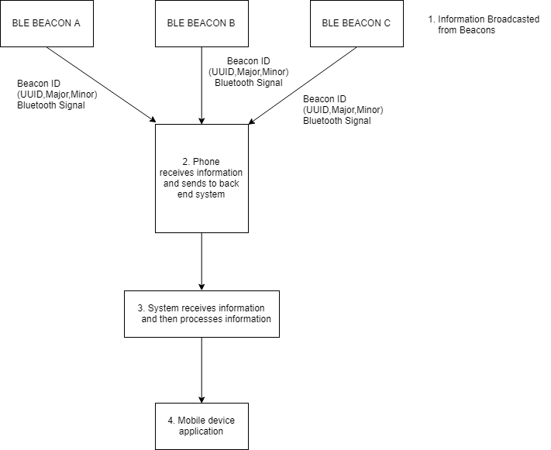

Figure 1.1: Overall system design

**2**

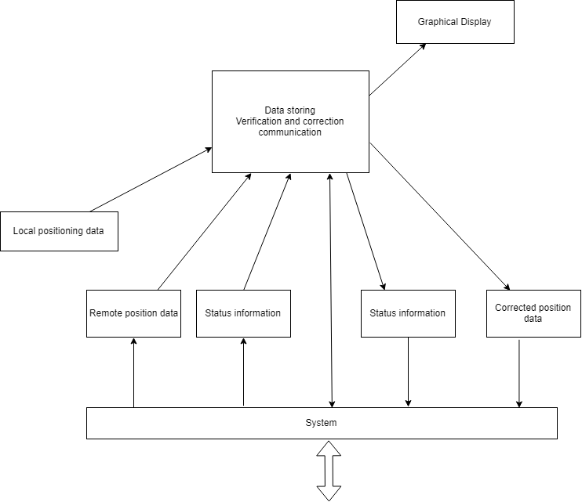

Figure 1.2: Overall System Architecture

**3**

**1.2.1 Bluetooth Low Energy and RSSI**

BLE shows a lot of promise in the form of a low powered wireless network. The hardware is portable, easy to deploy, and readily available. Nearly all smartphones today support BLE and there is a large developer community. A beacon is a BLE hardware capable of advertising data at regular intervals. A smartphone can listen to a beacon and get data from the beacon without a physical connection. This means that a smartphone can listen to a lot of beacons at the same time, getting all the nearby data quickly and easily. This connection-less data transfer is the biggest strength of the beacons.

Beacons can also be used to estimate distance to the receiver using a concept called the Receiver Signal Strength Indicator (RSSI). It is the signal strength (in decibels) measured by the receiver (ex. smartphone) when receiving packets from the transmitter (ex. beacon). RSSI reduces as the distance increases, so that we can approximate the distance using the reading. A Beacon’s data typically contains the following information:

1. ID – unique to a beacon

2. Name (optional)

3. Calibrated RSSI at 1m (iBeacon)

4. Calibrated RSSI at 0m (Eddy stone)

The calibrated RSSI is the expected value of RSSI read by the receiver when it is at the corresponding distance from the beacon. This value is found by actual measurements and then coded into the beacon to transmit. This value is very useful, as explained in the Distance Calculation section.

**4**

**1.2.2 FACTORS AFFECTING THE RSSI**

The RSSI measured for a beacon can be affected due to a lot of factors, which include:

1. Distance – the larger the distance between transmitter and receiver, the lower the RSSI.

2. Environment – walls, furniture, and other objects which cause signal attenuation, absorption, or reflection. Each of these would reduce the RSSI value compared to the Line of Sight (LoS) reception.

3. Obstructions – (such as people) in between the transmitter and the receiver reduce the RSSI value.

4. Transmitter antenna power – the higher the power, the higher the RSSI value, but lower the battery life.

5. Receiver antenna sensitivity and gain setting – more sensitive devices read higher RSSI values.

6. Transmitter and Receiver orientations

7. Air density affects the path loss which in turn affects RSSI values. Most of these factors are not in the user’s control, and so the RSSI readings obtained over time contain a lot of noise. It can get difficult to get a constant RSSI value, even if the user doesn’t move an inch.

**5**

**1.2.3 DISTANCE CALCULATION**

In order to calculate the distance between a smartphone and a beacon, an equation needs to be expressed and solved. The following equation from the Android Beacon Library can be used to calculate the distance:

D = C1 ∗ RSSI Txpower C2 + C3 (1.1)

The RSSI variable is the received signal strength indicator measured by the smartphone when reading the beacon and the Txpower is the value of the RSSI at one-meter factory set by Estimote. The constants C1, C2 and C3 are dependent on the smartphones Bluetooth chip and antenna and can be calculated for a specific device. The equation used in this thesis is expressed as following:

D = 0.89976 ∗ RSSI Txpower 7.7095 + 0.111 (1.2)

The distance D that is retrieved from the above equation is the distance from the smartphone to the beacon used in the trilateration calculations

**1.2.4 TRIANGUATION**

Triangulation is an old technique used to calculate an unknown position given two known points. This is the same technique used by the Greeks to calculate the radius of the Earth’s orbit around the sun. This technique allows you to find your position if you know two other given points and their belonging angles. With the knowledge of the position of a given point it is possible to calculate the distance to it

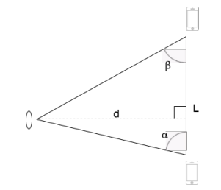

**6**

d = L sin(α) sin(β) sin (α + β) (1.3)

By using the equation 1.3, which combines the side L and the two known angles α and β, it is possible to calculate the distance d to the observer. This means the relative position from the two known points and is illustrated above

**1.2.5 Trilateration**

Trilateration is, like triangulation, a technique used in order to calculate a position. While angles are crucial if you want to use triangulation, trilateration is about measuring distances. This technique requires three known access points (APs) and the measured distance from them to the searched device. These distances can be measured by the RSSI value. When the positions and the distances are known, the position of the searched device can be calculated. This technique can however be used with more or less APs. As seen in figure a position will be more accurate the more APs are used. If only the AP A is used, the exact position cannot be calculated. It is located somewhere on the circle with centre A and radius being the distance from A to the device. This is also known as proximity based positioning. The equation describing this circle is:

$$d^{2}\text{ = }{\text{(x – xa)}}^{2}\text{+ }{\text{(y – ya)}}^{2}\text{ (1.4)}$$

where d is the distance, {xa, ya} are the coordinates of A and {x, y} are the unknown coordinates of the searched device. Adding the AP B, it is possible to exclude all but two positions. Since both APs A and B know their distance to the searched device it is possible to calculate the two points, more particularly the two intersections of the circles. It is also known as bilateration and the solution is obtained by solving:

$d^{2}\text{a}\text{ = }{\text{(x – xa)}}^{2}\text{+ }{\text{(y – ya)}}^{2}$

$d^{2}\text{b}\text{= }{\text{(x –}\text{ xb}\text{)}}^{2}\text{+ }{\text{(y –}\text{ yb}\text{)}}^{2}$

where da, dB are the two known distances, {xa, ya} and {xb, yb} the known coordinates of A and B and {x, y} the unknown coordinates. In order to calculate the exact position of the searched device, a third AP C needs to be added. It is then possible to exclude one of the earlier computed intersecting points and thus get a final position. This is done by solving these three equations:

$d^{2}\text{a}\text{ = }{\text{(x – xa)}}^{2}\text{+ }{\text{(y – ya)}}^{2}$ (1.5)

$d^{2}\text{b}\text{ = }{\text{(x – x}\text{b}\text{)}}^{2}\text{+ }{\text{(y – y}\text{b}\text{)}}^{2}$ (1.6)

$d^{2} \text{c}\text{ = }{\text{(x –}\text{ xc}\text{)}}^{2}\text{+ }{\text{(y –}\text{ yc}\text{)}}^{2}$ (1.7)

where the two first equations are the same as in equation, referring to A and B, and the third referring to C. One unique point with coordinates {x, y} which satisfies this system. Using RSSI values, there is a good chance that the distances are erroneous and could result in non-intersecting circles. The APs could also be placed so that the circles are overlapping without intersecting with each other. Both scenarios would result in an unsolvable equation system. Theoretically, it means that the position cannot be calculated.

**7**

**1.2.6 Approach to Indoor Positioning**

Indoor positioning can be generally approached in two ways: precise and zone based. Precise indoor positioning implies identifying the exact user position at all times, with an accuracy of up to one meter. It involves measuring the distance of the user from fixed points nearby, whose positions are pre-known (these fixed points can be beacons in case of BLE, and Wi-Fi Access Points in case of Wi-Fi, etc.), and using trilateration to calculate the user position. Trilateration is also used by GPS for outdoor positioning.

Zone based indoor positioning involves creating multiple zones to cover an indoor location, and then identifying the zone in which the user is currently present. The zones could be as small as 1m x 1m (for example, adjacent to a painting in a museum), or as large as 10m x 10m (for example, a hall). Thus, the zone size could be decided by the administrator during initial setup, depending on the accuracy desired. For BLE, this approach uses the concept of proximity from a beacon, where we classify a user as located Immediate, Near, or Far from a beacon. This gives us an estimate of the user’s position without involving too much computation. Immediate range is usually defined as less than one (or sometimes two) meter(s). Near range is usually between two and six meters. Far range is usually beyond six meters.

BLE Beacons work best with the zone-based approach because the noise in RSSI leads to error-prone distance calculations preventing a precise positioning. In the remainder of this report, we discuss the experiments and results of the zone based approach.

**8**

**1.2.7 Zone Based Approach and Calibration**

In case of the zone based approach, a system calibration must be done to define the values of Immediate, Near, and Far ranges. For example, the Immediate range could be under a meter, the Near range could be between one and six meters, and the Far range could be beyond six meters. In this case, the user can stand exactly one meter away from the beacon, facing it, and record the RSSI readings on his/ her phone. The mean value of these readings would define the boundary of the Immediate range. Similarly, the mean value of the RSSI readings at six meters, combined with those at one meter, would define the Near range, and likewise the Far range. Once the calibration procedure is complete, the recorded values are stored in a database, which would then be queried at runtime to establish the zone for a given beacon, using the measured RSSI value.

Such an implementation results in gradual boundaries instead of sharp ones, since the RSSI can vary slightly at the edges of the various ranges. As an example, the Near range could have an upper limit falling between 5 and 7 meters, rather than a crisp 6 meters. This variation is usually acceptable in most scenarios. RSSI values depend on the transmit power, so different beacons with different configurations of transmit power would result in different. RSSI values at the same distance.

Thus, ensure that beacons have the same transmit power before proceeding with calibration. Another important point is that RSSI readings vary from handset to handset, and this is a key problem considering different Android based phones. One way to compensate for this variation is to use a good quality (high sensitivity) phone and calibrate while standing a little further away from the desired range limit. For example, when calibrating for Immediate range to be up to one meter, calibrate while standing at 1.2-1.5 meters. The signal level picked up by a high sensitive phone at 1.2-1.5 meters can be at the same level as a low sensitive phone at one meter. Similarly, near range could be calibrated at 7 meters instead of 6 meters. This way we can accommodate various handset models.

**9**

**1.3. PROBLEM IN EXISTING SYSTEM**

The positioning system that deployed, presented the following categories of challenges: accuracy, availability, stability. By accuracy problem we denote that the system didn't always

provide the correct position within the specified allowances (nearly 1.5m). Availability problems are defined as not providing results within a constrained time limit (nearly 3 sec). Stability

problems refer to not providing consistent results (especially when a user is in a borderline position). The problems in each of these categories can be further classified as inherent, constrained, or implementation-related. Inherent refers to the fact that this is a built in feature of such systems. For example, a system can't determine the line of gaze (i.e. which exhibit is the user is looking at). Constrained concerns itself with the fact that the system in its present

technology has certain limits (i.e. a position can be determined only within nearly 1.5m). Implementation problems are connected with the specific implementation of the system,

like bugs, ill-defined API, responsiveness, etc. There are variety of reasons for these problems, rooted in the specific characteristics of the technology, as well as the specific environs:

• Transmission power setup, and threshold patterns impact the area A where a Beacon is Detected by Blinds and cause “false negative” person not detected at positions.

• Human body shield detection by the Beacon and may cause “false negative”.

• Metal, glass and other reflective surfaces may cause erroneous” false positive” detections in wrong places.

**1.3.1 Solution of these problems:**

The proposed solution is formulated via a multi-layered approach. On the hardware level (Beacons, Blinds, gateways antennas), the solutions consisted of using different antennas, individual configuration of Beacon transmission power, and physical location of Beacons and gateways. Beacon transmission power is constrained as follows: the higher the power the better the detection, the drawback interference and detection of Blinds while they are in nearby positions. So the power levels are tweaked in order to provide an optimal solution as possible. Solutions at the firmware level consisted. The proposed solution is formulated via a multi-layered approach. On the hardware level (Beacons), the solutions consisted of using different, individual configuration of Beacon transmission power, and physical location of Beacons. Beacon transmission power is constrained as follows: the higher the power the better the detection, the drawback interference and detection of Blinds while they are in nearby positions. So the power levels are tweaked in order to provide an optimal solution as possible. Blind A may be in close proximity to Blind B but not detected at any specific position, while Blind B may be detected at a certain position, we infer that A is at the same position as B. While the above provided solution to “false negatives”, it didn't deal with reflections and irregularities of antenna patterns. As part of our attempt at a solution we introduced a software filtering layer whose purpose was to consider the spatial layout. The reasoning in this layer is based on the time it takes a user to move from a place to another.

**10**

**1.4. PROJECT STATEMENT**

Outdoor positioning has already been tapped to its best potential and next natural step is moving indoors. The current outdoor positioning technology (mainly GPS) does not extend to the indoors due to loss of GPS signal. This has called for a need to develop innovative indoor positioning technologies. This need for indoor positioning for pervasive mobile computing has led to a lot of interesting research in the past ten years. Some of the initial research included use of specialized emitters and sensors placed inside buildings to localize objects and people. This method though quite accurate is not scalable for commercial deployments and involves a certain overhead cost in installing and maintaining the additional infrastructure. Another popular method makes use of the existing infrastructure using wireless access points to triangulate and localize using mobile devices.

This method is quite accurate but it usually requires extensive surveying and training effort to build a radio frequency (RF) map of the building. There are also improvements to this method which reduce the efforts or eliminate them completely but at the cost of accuracy. With mobile technology becoming more powerful over the last few years, it is now embedded with more sensors which can improve the accuracy of the prediction by combining them with these earlier technologies.

**1.5. OBJECTIVES**

Indoor positioning as mentioned above is a research area that has attracted quite a lot of attention recently. A lot of work has been done on different innovative approaches to solve this problem. In this project I will analyse these technologies for advantages, disadvantages from a practical deployment point of view, and then implement a system combining the best and most practical technologies to increase the accuracy of location prediction. The goal is to bring together these technologies that currently exist in silos and create a working implementation.

I will be implementing these technologies on the Android platform creating an Android application that can localize a user using just the phone itself. It should also be extensible to localize in other places as well.

**11**

**1.6. SCOPE**

1. Performance of the positioning system can be further improved by using algorithms namely Extended Kalman Filter and Unscented Kalman Filter.

2. Accuracy of the position system may be still improved by the appropriate deployment and proper number of fixed wireless receivers.

3. Experimental model could be developed to validate the accuracy of the different positioning systems.

4. This work can be extended to the development of Disaster Recovery Systems to save the lives of people during earthquakes, train accidents and tsunamis.

5. It could also be used to recover humans and pets etc. when they are trapped due to a fire outbreak on the top floors of a building.

**12**

**CHAPTER 2**

**BACKGROUND**

**2.1. REALTED WORK**

This chapter introduces earlier researches done in similar areas. The application developed in this thesis is composed of two parts: an IPS system needed to locate the users and a tracking system for locating the lost assets. Works about IPS and examples of tracking systems will therefore be reviewed. As mentioned in the introduction, since our application in based on crowd-sourced localization, meaning that the system needs active users in order to work, related work covering this area will also be reviewed.

**2.1.1 Indoor Positioning Systems with Bluetooth**

Bluetooth can utilize RSSI to be a technique for measuring positions indoors. Sheng Zhou el at. have made such a system where they turned off the automatic transmitter power control to get a novel use of the RSSI. The distance was estimated by transmitting between a mobile receiver and a reference point. They were also using a Line-Of-Sight radio propagation model within a single cell. The ability to navigate indoors using BLE and a smartphone has been studied by Milan Herrera Vargas. The author set up an indoor environment composed of two BLE beacons and a smartphone. He claims that the main purpose of his report was to introduce indoor navigation based on BLE but that this technology is still limited which led to unstable measurements and bad accuracy. The bad accuracy is an interesting aspect of IPS and is a known issue. Silken Feldman et al. have in their scientific paper tried to overcome this problem with and optimization method least square. They got a precision of 2 meters but think it could be even better by using a Kalman Filter. Tengqingqing Ge made a comparable research about indoor navigation but focused on making it available for blind people. By using BLE beacons and a smartphone, he developed and compared two different positioning software. The first one, based on triangulation and fingerprinting, gave good a static performance, but was not a reliable navigation system. In the second software a proximity algorithm was instead used, along with a real blind person. This experiment gave on the other hand a better output letting him conclude that a blind person was able to navigate through the route without any help from other people.

**13**

**2.1.2 Other approaches to IPS**

Instead of using Bluetooth, other technologies can be used to calculate positions. Examples of such approaches are presented below.

**2.1.2.1 Wi-Fi based localization**

Wi-Fi based localization is probably the most common technique used for IPS. Behrang Parhizkar et al. discuss such a solution as they try to position a user within a building. Thomas J. Gallagher et al. are also utilizing the Wi-Fi technology as they describe a campus-wide positioning system at the University of New South Wales in Sydney, Australia, and works outdoors as well as indoors.

**2.1.2.2 Geomagnetic Technology**

Indoor Atlas is an IPS company using the earth’s magnetic field in order to calculate positions. By using the compass which works as a magnetic sensor, it is possible to use the magnetic fields inside a building to accurately pinpoint and track a user’s position indoors. Geomagnetic is the foundation of this technology but together with Wi-Fi and beacons is it possible to develop a hybrid solution in order to reach optimization.

**2.1.2.3 Image based localization**

Today’s smartphones are equipped with many different sensors. Instead of using Bluetooth or Wi-Fi sensors, the smartphones camera can be used for IPS. An augmented reality kind of IPS can be done by comparing pictures taken by the camera with a sample of pictures stored in a database. It is then possible to position the smartphone.

The camera can also be used for visible light communication. This approach uses the emitting light itself, and can provide very good accuracy as well as being free from radio frequencies. These two approaches are however dependent on the line of sight which can be problematic for passive positioning when the smartphone camera is obstructed (in a bag or a pocket).

**14**

**2.2 Tracking Systems**

Another way of using a smartphone and BLE is for tracking lost objects. Tracker is a commercial solution using smartphones, GPS and BLE beacons to track lost assets in outdoor environments. A recent released scientific journal is also studying this kind of system. Both are reviewed below.

**2.2.1 Tracker**

Tracker is a crowd-sourced localization product made by Phone Halo. The idea is to put a Tracker device on a bike, key-ring or another item that tends to get lost. Using the Trackr application, which always registers the last known position of the Trackr device, it is possible to see where the lost item is located. Trackr uses BLE, and when one is within Bluetooth range, it is possible for the application to measure the distance to the lost item with help of RSSI. If the lost item is small and hard to detect, it is possible to make the device beep when one is within Bluetooth range. As mentioned, Trackr is using crowd-sourced localization. This is a concept where passive users of the application, the crowd, facilitates the search of the lost item. This is because the Trackr application does not only register the signal from your own belongings, but of all Trackr devices. If you lose your item, you will get noticed as soon as another Trackr application is within Bluetooth range of your lost object. Trackr will save the GPS position of the user and display it in your smartphone. In order to work properly, it is necessary that many people use the product. If one loses an item, and nobody register its signal, the whole concept is of no use. This means that crowd-sourced localization will work very well in large populated cities like Los Angeles where a lot of people will have a chance to register Trackr devices. At the same time, it will not work equally good in smaller cities where there are less people on the move and the probability to catch the signal is smaller.

**2.2.2 Personal Tracking via Bluetooth**

"Never Lose! Smart Phone based Personal Tracking via Bluetooth" is a scientific journal written by Saleem Ahmad, Prof. Lu Rouyu and Muhammad Jawad Hussain. The authors made a study on asset tracking where they presented different approaches to the problem. They also reviewed existing technologies and conducted a survey in China, UK and USA about personal tracking systems. Later on, they discussed the benefits and drawbacks of using BLE compared to other wireless technologies. Choosing Bluetooth as a tracking technology provides coverage for both indoor and outdoor usage with meter accuracy. BLE is currently installed in most smartphones, it is battery efficient and does not requires much computation power. The low installation costs also make it the best candidate compared to GPS, GSM, Wi-Fi and other techniques compared in the study. The accuracy of Bluetooth can however be a limitation, but the authors propose that Bluetooth could be assisted by audio or visual aids.

**15**

The survey was answered by 1000 participants, 69% of them being unaware of the tracking possibility of their smartphones. Almost all of them, 92% thinks a tracking system could help finding lost assets. The authors conclude that such systems will need to be low-cost and energy efficient in order to be adopted at large scales.

**2.3 Crowd-sourced localization**

Some researches within IPS have begun to explore the concept of crowdsourced localization. This concept is mainly about collecting vital data from the users of such systems. By continuously collecting user data, Yongduo Wang et al. proposed an IPS solution based on Wi-Fi RSSI data, collected by using the crowd. The positioning method used in their approach is fingerprinting. Fingerprinting is a common method, resulting in good positioning accuracy but requires a lot of data to build the fingerprint database. This is why the motivation for using crowd-sourced data is for simplifying the creation of their fingerprint database. The collected data also helps improving and updating the database after its creation. Anshul Rai et al. developed a system called Zee which is also based on crowd-sourced localization. They investigate a hybrid solution of using both Wi-Fi signals but also a smartphones sensor like the gyroscope and the accelerometer. This data is also collected using the crowd and permits to position the users without knowing their initial location, by looking at the number of steps they have walked, the direction they are facing and the velocity of the walk. Other users that needs to be located can then benefit from the fingerprint database obtained from these previous observations. Jindan Zhu et al. discussed about the main problem with crowd-sourced systems, which is the need of having active users collecting the vital data. The lack of users is the biggest limitation of such systems, and they tried to overcome this problem by combining Wi-Fi fingerprints with signals from BLE beacons. This particular approach of using data from beacons to support the lack of user data, let the authors of this paper improve the quality of their fingerprint database. Their work however showed some weakness for positioning the users, because it requires the users to be immobile in order to get a good accuracy and the calculations requires time and cannot be processed in real time.

**16**

**3.RESULTS**

The results are presented in table below. Here, we can see that the error rate generally

|  |  |  |  |  |  |
| --- | --- | --- | --- | --- | --- |
| Position | 1 | 2 | 3 | 4 | 5 |
| Correct estimates | 70% | 60% | 75% | 70% | 64% |

stays very low but increases to 25% when the device is close to the wall. This happens because the signals coming from the neighbouring room are not diminished sufficiently by the wall in order for the system to be able to completely distinguish between the two beacons on each side of the wall.

We started by plotting the RSSI graphs at various distances, using multiple sets of beacons and phones. First, we placed 10 beacons in a grid based layout in an office space (30m x 30m). Any two beacons had about 6 meters’ space between them. These beacons were pasted on the walls or pillars, with a placement height of 2 meters from the floor. We recorded RSSI values for a particular beacon, facing it; with the phone held horizontally at a height of about 1.2 meters from the floor (this scenario imitates a user standing with the phone in his/her hand). The beacon was always at line-of-sight from the phone. We started close to the beacon (1 meter apart) and gradually walked backwards, crossing 5 meters, facing the beacon all the while. For the purpose of this whitepaper, we set the beacons to -12 dBm of transmit power. When varying the transmit power, we observed similar behavioural patterns (higher power leads to higher RSSI). We created a custom app to measure RSSI values, and also used the Beacon Toy app to confirm that our app performed similar to a known app in the field. The result for one such measurement is shown in below. Note that IBeacon mentions that for a beacon transmitting at -12 dBm, the RSSI1m should be -77 dB, the reference graph for which is shown below.

Copy of Power Curve Distance Formula Calculation(observation).xlsx

In file above, as seen here, a lot of noise is present in the readings, due to which it is hard to know the accurate value. To compensate for this noise, we created a custom low-pass filter with a thresholding technique, such that sudden large variations in RSSI were ignored, and gradual small ones were accumulated. The filtered output was then used for our zone-based approach.

**17**

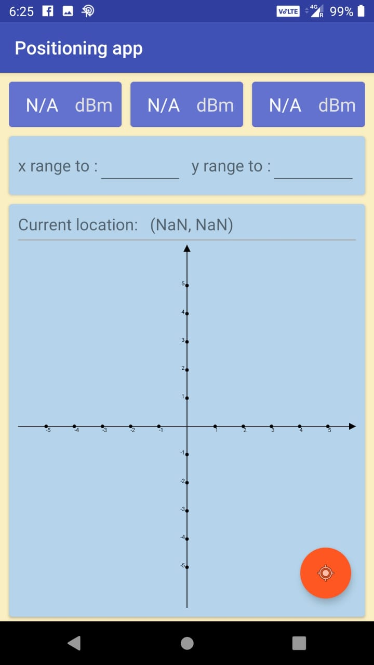

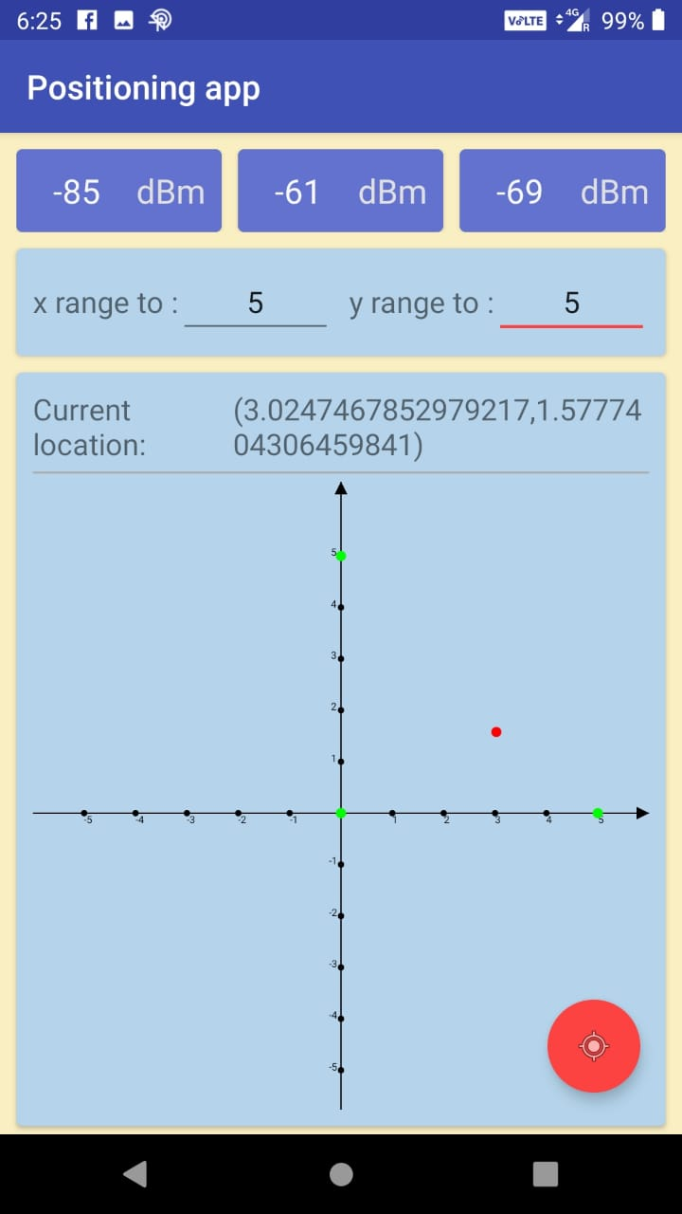

**18**

**4. CONCLUSION**

The aim of this project was to investigate and develop a new approach of an IPS which tracks down a lost object and relies on the users of the application. Was it possible to use only cheap BLE beacons and then let the more expensive parts of the system be the user’s smartphones? To make this possible, we needed to combine an earlier approach of an IPS, where a user can be positioned relative to the room, and combine it with the crowd-sourced localization technique. In addition to this, we needed to evaluate how many users were required to run the application in order to get a fast and reliable result. By measuring the accuracy of the beacons, it was possible to see how accurate the application would turn out to be. Unfortunately, the beacons used in this master thesis are intended for proximity and not range, which gave us uncertain results. Besides testing the accuracy of our application, we also needed to find out how many users it would take to find the lost asset in a reasonable amount of time.

Worth to mention is that the environment in the simulation is generic and have no obstacles at all. This means that the number of users needed to find the asset can be accurate if the system is used in an open field, but otherwise not. In addition to testing the software of our application, it was also necessary to do a user survey to see if people would be willing to run the application in background mode on their smartphones. If no one would use it, the whole concept of our work falls apart. The result showed that about 8 out of 10 would be willing to run the application, if its cause was to help other people finding things they had lost. If the cause of the tracking was instead to help a company find their lost assets, only a little less than the 50% would run the application. However, if the company started to give advantages to the users using the application, most of them who answered "no" in the first place could change their minds. Important to remember is that the results from the survey are not representative since the people answering to it are in our own age and have similar interests. Our conclusion is that we know that the application works and fulfils our preconditions, if enough people use it. Even though it does not always give an exact position due to unreliable accuracy, it is good enough to give the user a hint of where the lost asset is located

**19**

**5. FUTURE WORK**

The accuracy to get a user’s position relative to the room is very good thanks to existing technology. The hard part has been to get a good accuracy of a lost asset relative to the user. As stated earlier, the beacons attached to the assets are not meant to return an exact distance, they instead work with proximity. This is the main cause of the unreliability of the accuracy in our tests. Besides this proximity beacon, Estimote also provides location beacons. This leads to the first possible extension of this thesis, replacing the current beacons with these location beacons. Since they are developed to track real-time positions, it would most certainly give us a more accurate position of our lost assets. Further on, the application has only been developed as a prototype which only has maps of our office. Since the area is small, it has been hard to make accurate conclusions about how many people who have to use the application in order to get the system work properly. This is why we created a program which simulated the use of the application. The simulator was built in a generic way which generated unrealistic results for real life situations. An improvement here could be to use existing network simulators combined with different human mobility models. For example, the simulation could take into account additional parameters impacting the wireless signals such as walls and interferences combined with a human mobility model simulating a walk in a store with a predefined path but with random stops and pace. The resulting simulation would be more realistic and different scenarios could be simulated and tested. Instead of simulating, another way is to test the application in a real environment with real users. This is an interesting and important investigation to make that will provide additional results to the ones from the simulations. In order to help overcome the accuracy problems of the system, audio or visual helps could be installed on the lost assets. Instead of searching for the object only with the help of the application, a signal like an alarm or flashes could be triggered when the user searching for the asset is close enough to it. The usability of the system could be greatly increased without having to find a way to increase the accuracy

**20**

**References**

[1] Fastble library - <https://github.com/FlyAndNotDown/BluetoothLocation>

[2] Kiba Library - <https://github.com/KiBa1215/CoordinateAxisChart>

[3] Marco Altini, Davide Brunelli, Elisabetta Farella, and Luca Benini. Bluetooth

indoor localization with multiple neural networks. In Wireless Pervasive Computing (ISWPC), 2010 5th IEEE International Symposium on, pages 295 –300,may 2010.

[4] G. Anastasi, R. Bandelloni, M. Conti, F. Delmastro, E. Gregori, and G. Mainetto. Experimenting an indoor bluetooth-based positioning service.In Distributed Computing Systems Workshops, 2003. Proceedings. 23rd International Conference on, pages 480 – 483, may 2003.

[5] M.Z. Barahim, M.R. Doomun, and N. Joomun. Low-cost bluetooth mobile

positioning for location-based application. In Internet, 2007. ICI 2007. 3rd IEEE/IFIP International Conference in Central Asia on, pages 1 –4, sept. 2007.

[6] Mortaza S. Bargh and Robert de Groote. Indoor localization based on response

rate of bluetooth inquiries. In Proceedings of the first ACM international workshop on Mobile entity localization and tracking in GPS-less environments, MELT’08, pages 49–54, New York, NY, USA, 2008. ACM.

**21**